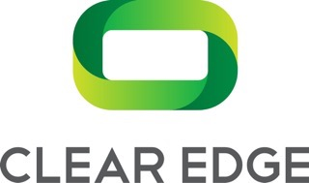

Informed Consent and Release Form

Background/Purpose:

ClearEdge® brings current clinical practices for assessing balance (ClearEdge Motion™) and cognitive function (ClearEdge DANA™) into an objective test toolkit. ClearEdge Motion is pending FDA registration and not currently available for commercial use.

All risks identified with ClearEdge Motion have been mitigated to an acceptable level. ClearEdge Motion passed testing for safety per international standards IEC 60601 by Intertek (a leading worldwide independent testing company for safety accreditation).

You/your child are being asked to take the suite of ClearEdge tests to ensure ClearEdge is ready for production release. Participation is voluntary and may be discontinued at any time.

ClearEdge Toolkit:

Under the oversight of a trained ClearEdge tester, you/your child will first be asked to use a tablet and headphones to complete a symptoms questionnaire (e.g., fatigue, dizziness), then a series of cognitive tests that will challenge speed and reaction skills (ClearEdge DANA™). After removing the headphones, the tester will have the child complete a series of balance tests while wearing our proprietary Edge™ Sensor on their back at waist level over their clothing (ClearEdge Motion™).

Benefits:

Each participant will receive a free brain health baseline test ($75 value). As ClearEdge Motion is still under regulatory review, results of the tests will not be available until FDA registration is compete. You will be sent an email notifying you of the process to login to review your results.

Please indicate your approval of your/your child’s participation by signing and dating below. Thank you.

Your Name and/or Child Name(s)/Age(s):

___________________________________________________________________________

_____________________________________________________________________________________________

____________________________________________ _____________________
Your Signature Date

